Types of DNS Security
# Source: AI Source: Provided by: [Data Path: Persons Table -> ID Column: 1, Name_En Column: Motasem Essam] -> From: [ChatGPT] on [1/18/2026]
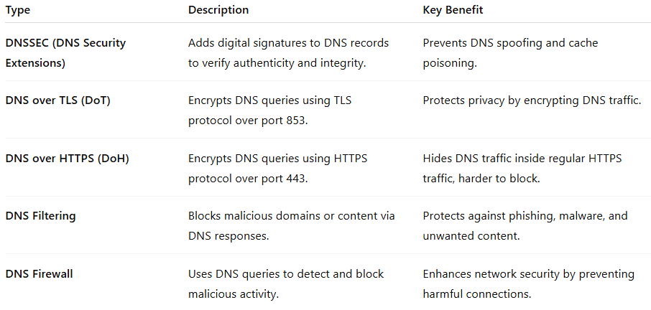

Type | Description | Key Benefit
DNSSEC (DNS Security Extensions) | Adds digital signatures to DNS records to verify authenticity and integrity. | Prevents DNS spoofing and cache poisoning.
DNS over TLS (DoT) | Encrypts DNS queries using TLS protocol over port 853. | Protects privacy by encrypting DNS traffic.
DNS over HTTPS (DoH) | Encrypts DNS queries using HTTPS protocol over port 443. | Hides DNS traffic inside regular HTTPS traffic, harder to block.
DNS Filtering | Blocks malicious domains or content via DNS responses. | Protects against phishing, malware, and unwanted content.
DNS Firewall | Uses DNS queries to detect and block malicious activity. | Enhances network security by preventing harmful connections.

